database management report

# Travis brown

Task 1: Insert Record to the Person Table

A screenshot of a cell phone

Description generated with very high confidence

Using INSERT INTO ‘table name’ () allows you to insert values into the selected table and the selected columns in (). VALUES() shows which values you want inserted into the corresponding columns chosen.

A close up of text on a black background

Description generated with very high confidence

Task 2: Alter the Person Table



Using ALTER TABLE allows you to pick which table you want to change, and the ADD operator allows you to specify the parameters for the column you want to add.

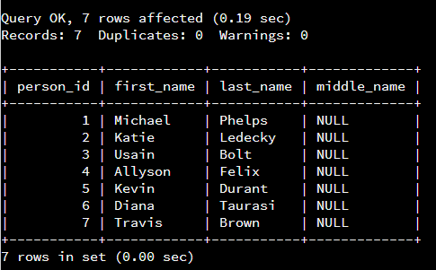

Task 3: Update Records in the Person Table

A picture containing object

Description generated with high confidence

UPDATE allows you to change existing information in a table. SET chooses which column you want to update. WHERE sets parameters on which records get updated.

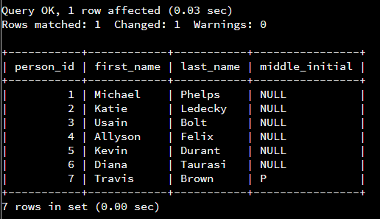

Task 4: Delete Records from Person Table

A close up of a logo

Description generated with very high confidence

DELETE FROM allows you to delete records from a selected table. WHERE and AND allow for multiple parameters to be met before the record is deleted, increasing the accuracy of the command and mitigating room for error.

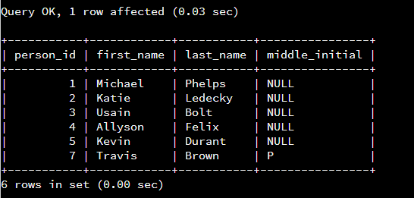

Task 5: Alter the Contact List Table

A close up of a logo

Description generated with very high confidence

A screen shot of a computer

Description generated with high confidence

Task 6: Update Records in the Contact List Table

A picture containing object

Description generated with high confidence

This script updates the contact list to make the person with contact_id of 1 everyones favorite.

A screenshot of a computer

Description generated with high confidence

Task 7: Update Records in the Contact List Table



This line of code changes every other person not a favorite.

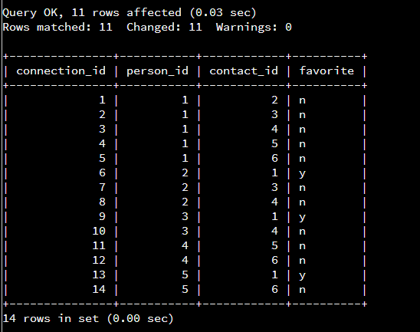

Task 8: Insert Records to Contact List Table

A picture containing indoor

Description generated with high confidence

This script adds three more rows of data into the contact list table

A screenshot of a cell phone

Description generated with high confidence

Task 9: Create the Image Table

A screen shot of a computer

Description generated with very high confidence

CREATE TABLE does just that. Inside the parenthesis are the code to create each column inside the table we are creating. INT(8), VARCHAR(50) and VARCHAR(250) are designating the data type to be stored in each column,NOT NULL specifies that the data is required to be filled, AUTO_INCREMENT=1 sets the number that each primary key increases.

A picture containing indoor

Description generated with high confidence

Task 10: Create the Message-Image Intersection Table

A screen shot of a computer

Description generated with high confidence

This script creates the table message_image which is a table consisting of two separate columns from existing tables. FOREIGN KEY() sets the column of the new table that will pull from an existing table, REFERENCES table name() decides which existing table and column it will pull from.

A black and red text

Description generated with high confidence

Task 11: Insert Records to Image Table

A screenshot of a cell phone

Description generated with very high confidence

This script inserts data into the image table created in task 9.

A close up of a screen

Description generated with very high confidence

Task 12: Insert Records to Message-Image Table

A screenshot of a cell phone

Description generated with high confidence

This script insert data into the message_image table created in task 10.

A screenshot of a cell phone

Description generated with high confidence

Task 13: Find All of the Messages that Michael Phelps Sent

A screenshot of a social media post

Description generated with very high confidence

SELECT states what columns we want to see. FROM states what tables we want to pull from WHERE and the AND operators narrow it down to pull only the data we need in the order we need it.

A close up of a screen

Description generated with very high confidence

Task 14: Find the Number of Messages Sent for Every Person

A screenshot of a cell phone

Description generated with very high confidence

SELECT COUNT(*) selects the number of times a certain parameter is recorded AS allows us to alias the selected table.

A picture containing wall

Description generated with high confidence

Task 15: Find All of the Messages that Have At Least One Image Attached Using INNER JOINs

A screen shot of a social media post

Description generated with very high confidence

INNER JOIN or just JOIN allows us to see multiple table.columns together in one table.

A close up of a black background

Description generated with high confidence